|  |
| --- |
| SG12-0006-01 | Francis Pang |



|  |  |
| --- | --- |
| ACE Insurance Limited | BOTL GENERATOR |

This guide aims to provide a step-by-step guide to generate an intermediate file for uploading into the System 6 database.

*Take note that the current BOTL Generator is only ready for testing on campaign SG12-0006-01.

**Step 1: Go to the ‘Person’ worksheet once you open the workbook.**

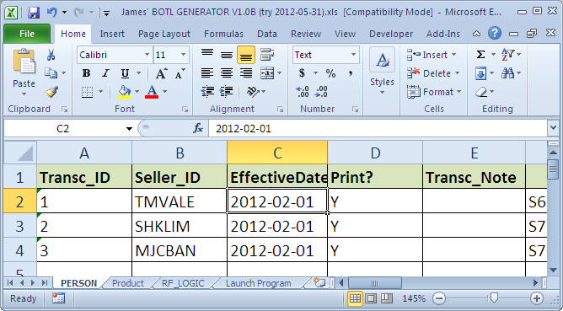

Figure 1: Go to 'PERSON' worksheet

**Step 2: Fill up the data according to the mapping of the heading below.**

* Each dependent (including spouse) of the policy holder will required a dedicated row filled with individual information in the worksheet grouped together by the same Transc_ID.

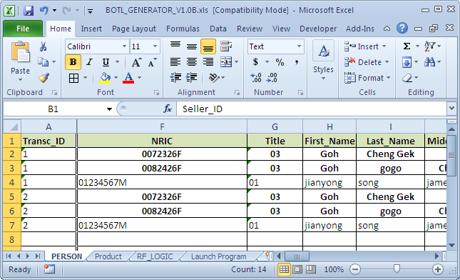

Figure : Transc_ID

|  |  |  |
| --- | --- | --- |
|  | Sub-heading | Additional Remarks |
| Transc_ID |  | The Transc_ID is meant to group the relevant personal in the same policy together. |
| Seller_ID | **Seller ID** |  |
| EffectiveDate | **Effective Start Date** |  |
| Print? |  | To indicate if the ‘SuperPrint print request’ option is on. Only ‘**print’**, ‘**noprint’** or ‘**suspend’** are allowed. |
| Transc_Note |  | Any note that you want to key in as the additional information for the policy. |
| NRIC | **NRIC/FIN** |  |
| Title | **Salutation** | The Salutation need to be translated to the title code as follows:  01 Mr  02 Mrs  03 Ms  04 Dr  05 Miss  06 Mdm  09 Prof |
| First_Name | **NAME** | Name need to spilt according to first name (surname), last name (given name) and an optional middle name. |
| Last_Name |
| Middle_Name |
| Birth_date | **Date of birth (dd/mm/yyyy)** |  |
| Sex | **Gender** | Only allow:  ‘01’ – Male  ‘02’ - Female |
| Relationship |  | Only allow:  ‘05’ Dependent  ‘08’ Spouse |
| Spouse? |  | Put ‘Y’ if the person is the spouse of the policy holder |
| Insured? |  | Put ‘Y’ if the person is insured in the policy |
| BENEFITING? |  |  |
| Payer? |  | Put ‘Y’ if the person is the policy payer |
| Dependent? |  | Put ‘Y’ if the person is the dependent/ spouse of the policy holder |
| Bill-Date |  | Leave it blank |
| Payment_method |  |  |
| Payment_Freq | **Payment Frequency** |  |
| CC_TYPE |  |  |
| CC_Expiry | **Card Expiry Date (mm/yy) (For Credit Cards Only)** | Only allow the format ‘MM/YY’ |

|  |  |  |
| --- | --- | --- |
| CC_NUM | **Account Number** |  |
| Bill_Name | **Name On Card/Account** |  |
| Insured_Freetext |  |  |
| Email |  |  |
| Address_Type |  | Please key in this according to the different address type:  01 Home  02 Mail  03 Work  15 Property  aa Email  ab Temphome  ac Tempwork  D3 Vacation |
| Address_Blk | **Address (Block No / Street Name)** |  |
| Address |
| Address_unit | **Address (Unit No.)** |  |
| address_postal | **Address (Postal Code)** |  |
| address_city |  |  |
| country_code | **Address (Country)** | Please put ‘SG’ for Singapore. |
| tel | **Home No.** |  |
| mobile | **Handphone No.** |  |
| Misc1 |  | Put ‘10%’ if there is 10% discount. |
| Misc2 |  | Leave it blank |
| Misc3 |  | Leave it blank |
| MISC4 |  | Leave it blank |

**Steps 3: Click on ‘Launch Program’ worksheet.**

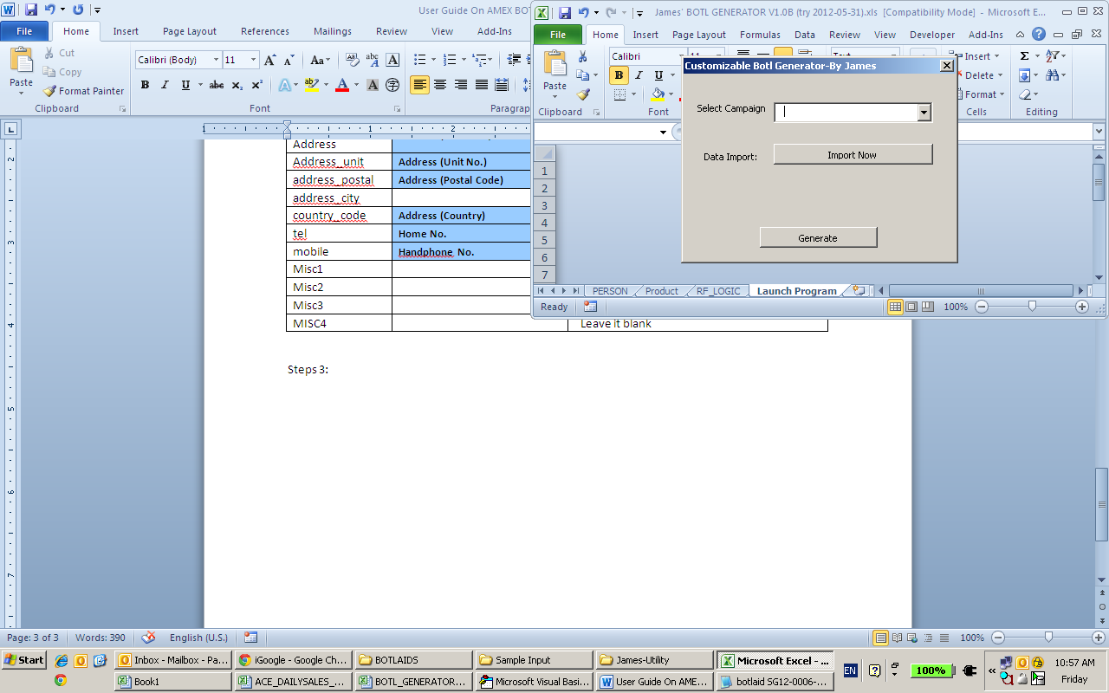

**Step 4: A box will appear. Select ‘SG12-006-01’ from the the drop down list under ‘Select Campaign’.**

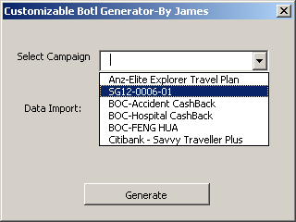

**Step 5: Click on ‘Generate’. A box with message ‘Done’ will appear. Click OK.**

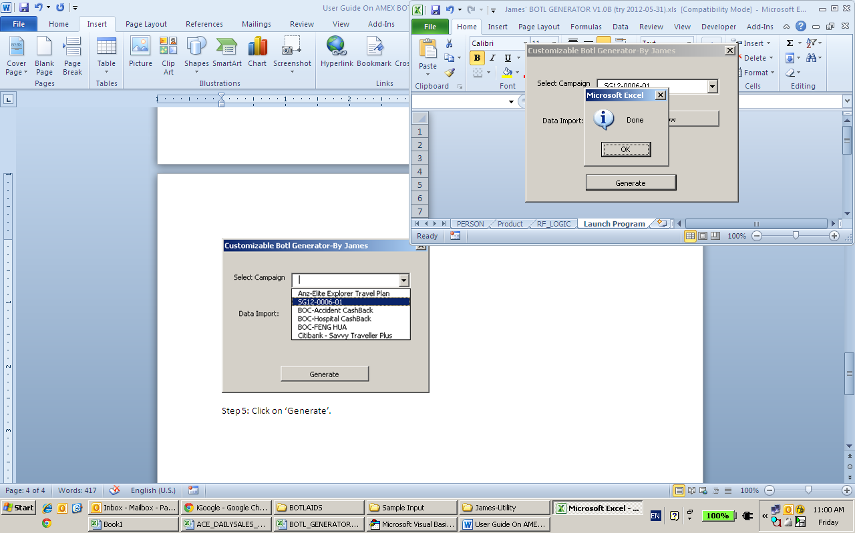

**Step 6: At the places where you store your ‘BOTL Generator’ excel file, there should be a file ‘output.out’ produced.**

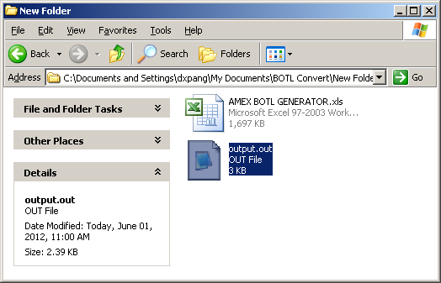

**Step 7: Send the file to the Technical Developer to assist you to put the data in System 6 (UAT) database.**